**BIOL5299 Pathogen Polyomics**

**STUDENT ID: 2060576**

Polyomics Report

A polyomics-based, and structural biology approach to investigating Amphotericin B resistance in Leishmania mexicana

**Abstract**

Leishmaniasis is a complex of diseases that affects around 1 -2 million individuals a year. It caused by the parasite Leishmania. The second line drug for treating leishmaniasis is the polene compound, amphotericin B (AmpB). AmpB’s putative mechanism of action is that it binds to the sterol (ergosterol) present in the Leishmania membrane. Signs of resistance to AmpB have been slowly on the rise, and ithus it is worth understanding the mechanism of this resistance, in an attempt to prevent and prepare for a rapid increase in AmpB resistance. The investigation involved comparing of the genome, metabolome of wild type and AmpB resistant Leishmania mexicana cells. The steroid metabolism pathway was the pathway associated AmpB resistance, with the mutation in residue 176 (N176I) of sterol 14α demethylase (CYP51) playing a major role.

**Introduction**

Leishmania are a genus of protozoan parasites that are transmitted by female phlebotomine sand flies, which are roughly geographically distributed across 88 countries. Leishmania infection in humans can lead to the development of leishmaniasis, a group of diseases. An estimated 12 million individuals are reported to be infected, with around 1-2 million new cases reported annually (Downing *et al*, 2011; Rogers *et al*, 2011; Hagrove *et al*, 2011; Mwenechanya *et al*, 2017; WHO, 2017). In addition to humans, other varieties of mammals are used as hosts over the course of the Leishmania life cycle. They grow as extracellular parasites (promastigotes) in the gut of the sand fly, and then become obligate intracellular parasites (amastigotes) upon transmission to a mammalian host (Bates, 2007; Hagrove *et al*, 2011). There are about 25 species of Leishmania known to cause disease in humans. Each of these have characteristic tropisms which are responsible for the different manifestations of leishmaniasis. The disease has four clinical syndromes: cutaneous (CL), mucocutaneous (MCL), visceral (VL), and diffuse cutaneous (where the parasite disseminates to other parts of the skin, following drug treatment) leishmaniasis (Hagrove *et al*, 2011; Rogers *et al*, 2011; WHO, 2017).

Presently, chemotherapy is mainly used to control leishmaniasis, as no effective vaccines are available. Two pentavalent antimonials (sodium stibogluconate, and meglumine antimoniate), and amphotericin B (AmpB), remain the most widely used clinical drugs (Hamdan *et al*, 2005; Hagrove *et al*, 2011). AmpB is the usual second-line drug of choice, administered either as free drug preparations (solubilized in deoxycholate), or in liposomal formulations. The later preparation is less toxic, and more efficient against Leishmania living inside macrophages (Hamdan *et al*, 2005; Lemke *et al*, 2005; Mwenechanya *et al*, 2017). AmpB’s putative mechanism of action is that it forms complexes with the sterol present in the membrane of its target cells. This leads to the formation of pores, and subsequent depolarization of the membrane. AmpB binds ergosterol (the major sterol in the membranes of fungi, and Leishmania) with greater avidity than cholesterol (the major sterol in mammalian membranes), making it a suitable drug for treating leishmaniasis (Lemke et al, 2005; Hamdan *et al*, 2005; Mwenechanya *et al*, 2017). Another proposed mechanism of action for AmpB is that it induces oxidative stress in the cells, by forming free radicals (Purkait *et al*, 2012; Mwenechanya *et al*, 2017). Despite the frequent and widespread use of AmpB over the past few decades, resistance to the drug has been slow to emerge. During this period, AmpB resistance has only been reported in fungal and Leishmania clinical isolates of immunocompromised patients, as well as in isolates from an Indian leishmaniases patient (Hamdan *et al*, 2005; Mbongo *et al*, 1998; Elis, 2002; Lachaud *et al*, 2009; Srivastava *et al*, 2011; Purkait *et al*, 2012; Mwenechanya *et al*, 2017).

Several studies have been conducted with AmpB resistant Leishmania lines to elucidate the mechanism(s) of AmpB resistance. Perhaps unsurprisingly, AmpB resistance was consistently observed to be associated with changes in the sterol biosynthesis pathway, mostly notably the significant reduction (or loss) of ergosterol from the membrane sterol composition. In resistant lines, ergosterol is replaced by a variety of cholestane-type sterols, which bind less avidly to AmpB (Mbongo *et al*, 1998; Hamdan *et al*, 2005; Purkait *et al*, 2012; Kumar *et a*l, 2014; Mwenechanya *et al*, 2017). Genes that code for enzymes contributing to the reduction of ROS build up, such as ascorbate peroxidase, and enzymes involved in thiol metabolism, were also observed to be significantly upregulated in AmpB resistant lines (Purkait *et al*, 2012; Kumar *et a*l, 2014). However, L. *mexicana* resistant lines generated by Mwenechenya *et al* (2017) were observed to be very sensitive to oxidative stress. This perhaps suggests that ergosterol itself might play a role in reducing oxidative stress, and that previous resistant lines may have inadvertently selected for resistance to oxidative stress. Mwenechenya *et al* (2017) were able to associate the changes in sterol metabolism with a single amino acid change, N176I, in the sterol 14α demethylase (CYP51) enzyme. This mutation was shown to provide L. *mexicana* parasites with a high level of resistance. The combined observation of the mutation, and the upregulated product of CYP51, 4,4-dimethylcholesta-8,14,24-trien-3β-ol, suggests that the mutation may have a downstream effect on the sterol metabolism pathway that prevents further reactions of its cholestane product.

The objective of our study was to gain an understanding of AmpB resistance in Leishmania, in terms of identifying genes, metabolites, protein conformations, and protein interactions that are in association with the phenotype. We approached this by combining data from genomic analysis, untargeted metabolomic analysis, and structural analysis studies on both the wild type (WT) and AmpB resistant L. *Mexicana* cell lines. The polyomics approach to this investigation provides set a of polymorphisms, in a set of enzymes that are associated with AmpB resistance. The effect of these polymorphisms on the structure of the enzymes can then be observed via the structural biology analysis, and thereby help elucidate novel mechanisms of the associated enzymes that confers resistance.

**Methods**

**Genome Analysis for variant identification**

The Genome Analysis Toolkit (GATK) workflow was used as a guide to identify variants associated with AmpB resistance. The data-clean up and preparation process began by trimming low quality bases (threshold 51; offset 64) from the 3’ end of paired-end raw reads of both the wild-type (WT) and resistant (res) L. *mexicana* species. The trim galore software was used to this, and it also automatically filtered reads shorter than 20bp ([https:/www.bioinformatics.babraham.ac.uk/projects/trim_galore/](https://www.bioinformatics.babraham.ac.uk/projects/trim_galore/)). The trimmed reads were then aligned to the L. *mexicana* reference genome using bowtie2 (<http://bowtie-bio.sourceforge.net/bowtie2/manual.shtml>). The SAM formatted output of aligned reads were then subsequently converted to a BAM format, sorted, and indexed with the aid of Samtools (<http://www.htslib.org/doc/samtools-1.2.html>). Samtools was also used to remove any PCR duplicates, so as not to have a skewed value when calculating allele frequency. Variants were called from this processed BAM file with the aid of FreeBayes (<https://github.com/ekg/freebayes>).

In addition to the reference genome, FreeBayes requires the ploidy of the genome, which was estimated as 2. The ploidy for each chromosome was calculated as [median coverage for chromosome/ (median coverage for genome/2)]. The median coverage information was retrieved from the BAM files with the aid of Bedtools (<http://bedtools.readthedocs.io/en/latest/content/bedtools-suite.html>). Once calculated, variants were recalled for chromosomes with ploidy less than/greater than 2. Variants with an estimated probability less than 99% (phred score: 20) were subsequently filtered out with the aid of Vcffilter (<https://github.com/vcflib/vcflib>). To select variants unique to the AmpB resistant lines, the set operators of the Variant Tool Chest were used extract the relative complements of WT variants from the VCF file of the AmpB resistant lines (<https://github.com/mebbert/VariantToolChest>). With the file of unique AmpB resistant variants obtained, the nest step in the analysis was to annotate these variants, and predict their effect. This was achieved with the aid of snpEff (<http://snpeff.sourceforge.net/SnpEff_manual.html>). Once annotated, variants with predicted impacts of HIGH/MODERATE were extracted from the annotated VCF file with the aid of SnpSift (<http://snpeff.sourceforge.net/SnpSift.html>). The gene ids from the resulting file were then extracted and imputed into TriTrypDB (a database for kinetoplastid genomic resources, <http://tritrypdb.org/tritrypdb/>) to identify metabolic pathways in LeishCyc and KEGG , and gene ontologies enriched by any of the variants (p-value cut-off of 0.05).

**Global metabolite profiling via an untargeted Liquid Chromatography-Mass Spectrometry (LC-MS)**

The metabolomic analysis was carried out on 8 samples, which consisted of four replicates each for the wild type (WT) and resistant L. *mexicana* group. Both the positive and negative molecular ions were acquired in the mass -spectrometry, where possible. The resulting metabolomics data was processed with the aid of a web enabled pipeline analysis tool, PiMP (Gloaguen *et al*, 2017). PiMP offers many statistical, annotation, visualisation, and pathway mapping tools, for processing chromatography-MS data. It is also able to integrate the results of these, allowing for an easier, and more user-friendly approach to selecting candidate metabolites in an untargeted metabolomics experiment.

The quality of the sample preparation, and the raw data was assessed with use of primary component analysis (PCA) plots, and total ion chromatograms. The total ion chromatograms for both positive and negative ions of each sample in a group were aligned. The purpose of this was to assess the reproducibility of the experiment. The peaks called from the LC-MS were then filtered on the basis of noise, range of points a peak must have, and peak width range. The retention time of the peaks were also corrected using the Obiwarp algorithm (Prince and Marcotte, 2006). The processed data, consisting of the peak information and their statistics, was formatted to mzXML. The processed peaks were annotated by matching their mass and mass/retention time to known standards, respectively. The success of such a process is largely dependent on the chromatographic resolution, and the amount of spectral information. The identified metabolites underwent a group-wise comparison to calculate fold changes, and plot intensity comparisons. The fold changes are associated with the significance statistics (p and adjusted-p values) of the peak data. PiMP was also able map the identified metabolites to pathways in KEGG, in an enrichment analysis.

**Investigation of N176I interactions within L. Mexicana CYP51, and with sterol C-14 reductase**

The structure of both the wildtype (WT) and mutant (N176I) L. *Mexicana* CYP51 were determined using Phyre2 (Kelley *et al*, 2015). Phyre2 is a biomacromolecular modelling server. It predicts the three-dimensional (3D) structure of a protein from its amino acid sequence. It does so by detecting sequence homologues present in PSI-BLAST, then predicting secondary structures and disorders, and then constructs a hidden Markov model (HMM) based on the selected template(s). This model is scanned against a library of HMMs, and the alignments are used to construct 3D models. The gaps produced by insertions and deletions are closed via loop modelling, and side chains are optimised with the aid of a rotamer library. The whole model then undergoes energy minimization (Kelley *et al*, 2015). These steps carried out in Phyre2 underline the principles of homology-based (or comparative) modelling. The intensive option in Phyre2 was used.

Other model structures for both the WT and N176I CYP51 were also generated using I-TASSER (Yang *et al*, 2015). This server, unlike phyre2, predicts the 3D structure on the basis of fold recognition (threading). It predicts the fold structure of an amino acid sequence, and ultimately whole models, using a structural database. These models are then energy minimized and scored.

The models generated from I-TASSER and Phyre2 were then scored using the QMEAN scoring function of swiss model (Benkert *et al*, 2008). The models were pdb formatted. The highest ranked model was selected for further analysis. The structural features of the chosen model were assessed in PyMOL (<https://pymol.org/2/)>. The annotated structural features of a very similar, experimentally determined, homologue (L. *infantum* CYP51), were used to annotate the structural features of the L. *mexicana* CYP51 (Hagrove *et al*, 2011). The pairwise alignment between the two protein sequences was performed using Clustal Omega (Sievers and Higgins, 2014). To properly annotate these features, the L. *mexicana* CYP51 structures (mex-CYP51) were aligned to the L. infantum CYP51 (inf-CYP51) in PyMOL. The experimentally determined structure of inf-CYP51 was retrieved from the RCSB protein data bank (PDB), PBD ID 3L4D. The WT and mutant CYP51 structures were also aligned. The root square mean deviations (RSMDs) of the alignment were calculated in PyMOL. The distance between the mutation site and the active site (in both WT and N176I) mex-CYP51 structures, were calculated using PyMOL’s measurement tool. Transmembrane regions of the proteins were predicted using CCTOP (Dobson *et al*, 2015).

The 3D structure of sterol-c14 reductase was also modelled using Phyre2. This structure was then docked to the mex-CYP51 structures using the ClusPro web server (Comeau *et al*, 2006; Kozakov *et al*, 2006; Kozakov *et al*, 2013; Kozakov *et al*, 2017). Distances between the N176I site, of the CYP51 structures, and any residue on the sterol-c14 reductase was calculated using PyMOL’s measurement tool

Results

Genome analysis

The genomes of the Wild type (WT) and AmpB resistant (res) L. *mexicana* species were analysed with the aim of identifying protein coding variants that may be associated with AmpB resistance. Our WT and res reads were reported to have an overall alignment rate of 71.39 % and 82.46 %, respectively. Freebayes was able to detect a total of 51353 variants, as well as report a quality score (that estimates the probability of the a polymorphism occurring at the site of a chromosome) for each allelic variant. This program was used as our variant caller because it is able to avoid the issue faced when aligning reads that match repetitive regions. The allele frequency calculation used in Freebayes (for reporting allelic variant probabilities) required information about the parasite’s ploidy. Freebayes assumes the ploidy for every chromosome is 2, and this was the ploidy value used when first calling variants. For proper functioning of Freebayes, ploidy for each chromosome was estimated. This estimation relied on the median genome coverage, and the median coverage data for each chromosome (Figure 1). The median genome coverage was estimated to be 80.

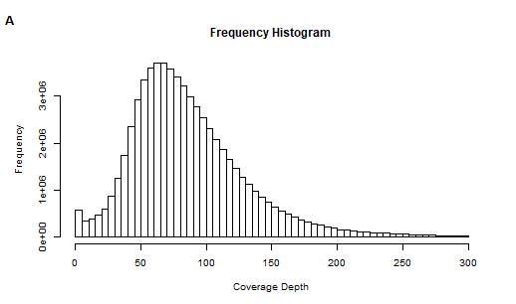

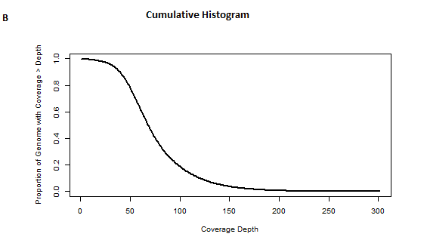

**Figure 1: Genome coverage data**

A: Histogram showing the frequency of each base at each coverage depth. Median of the histogram is calculated as 80.

B: Line histogram showing the proportion of genome occupying a coverage depth. 50% of the genome is observed to have a coverage depth of about 80.

Chromosomes with ploidy greater/less than 2 were subjected to a second variant calling. Upon filtering out allelic variants with a phred score below 20, 42894 variants remained. 1530 of those were unique to the res sample, relative to the WT sample. These variants were then annotated, and those located in coding regions, with impacts indicated as high or moderate, were then extracted. The total number of variants extracted was 174, with 17 of them predicted to have a high impact (data not shown).

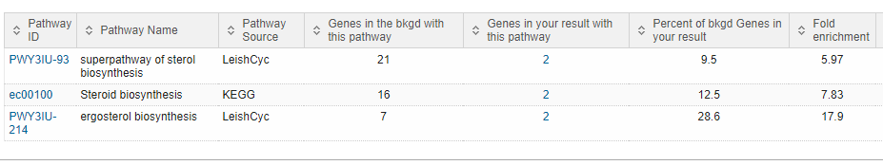

**Table 1: Metabolic pathway enrichment result for a set of 174 allelic variants via TriTrypDB**. Two genes from these variants enriched for the sterol (ergosterol in Leishmania) biosynthesis pathway.

Metabolic enrichment analysis done in TriTrypDB (a kinetoplastid genomics resource), using the gene ID’s in our final set of 174 variants, showed that the ergosterol biosynthesis pathway was enriched by two of our genes (Table 1). These genes code for the proteins Lanosterol 14-alpha demethylase, and sterol 24-c-methyltransferase. The amino acid changes observed in the res samples were an asparagine to isoleucine, at residue 176 of the lanosterol demethylase, and a valine to isoleucine at residue 321 of the sterol methyltransferase. Both allelic variants were homozygous (Table 2 and 3).

|  |  |  |  |  |  |  |
| --- | --- | --- | --- | --- | --- | --- |
| **Gene ID** | **Impact** | **Effect** | **HGVS_C** | **HGVS_P** | **Genotype** | **Chromosome** |
| LmxM.11.1100 | MODERATE | missense_variant | c.527A>T | p.Asn176Ile | 1/1 | 11 |
| LmxM.36.2380 | MODERATE | missense_variant | c.961G>A | p.Val321Ile | 0/0 | 20 |

**Table 2: Description of allelic variation in the two genes identified from metabolic pathway enrichment.**

|  |  |  |  |
| --- | --- | --- | --- |
| **Gene ID** | **Position** | **Organism** | **Product description** |
| LmxM.11.1100 | 443299 | L. mexicana MHOM/GT/2001/U1103 | Lanosterol 14-alpha demethylase |
| LmxM.36.2380 | 951390 | L. mexicana MHOM/GT/2001/U1103 | sterol 24-c-methyltransferase, putative |

**Table 3: Description of protein product encoded by genes identified from metabolic pathway enrichment.**

Metabolome Analysis

The aim of this analysis was to discover whether there were any concentration changes between metabolites in the wild-type (WT) and AmpB resistant L. *mexicana* cells. The approach used to carry out this investigation was an untargeted liquid chromatography-mass spectrometry. The data generated from this experiment was processed using PiMP (Gloaguen *et al*, 2017). PiMP was able to perform some quality control on the experiment by generating PCA plots and total ion chromatograms (TICs) for the samples (Figure 2). The PCA showed that the WT and resistant lines were clearly different from each other. The group specific alignment of each TIC revealed the data of the experiment to reproducible. This, as a result, suggests that the data generated within groups can be compared and combined in good confidence. There was a total of 3,144 processed peaks. The annotation of the processed peaks resulted in 56 unique compounds that match to a known standard. Many of the peaks could not be identified, as the final list of metabolites was a total of 2,811. 360 peaks were observed to be significantly changing, with slightly more metabolites showing less concentration, as we move from the WT to resistant lines, than more concentration (Figure 3).

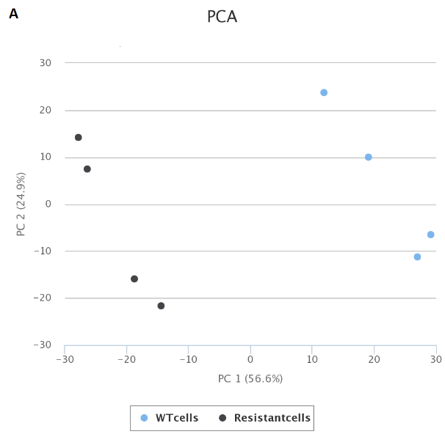 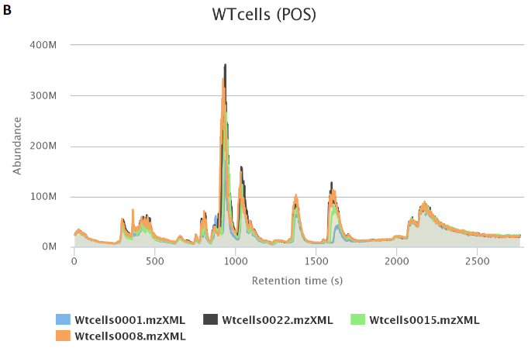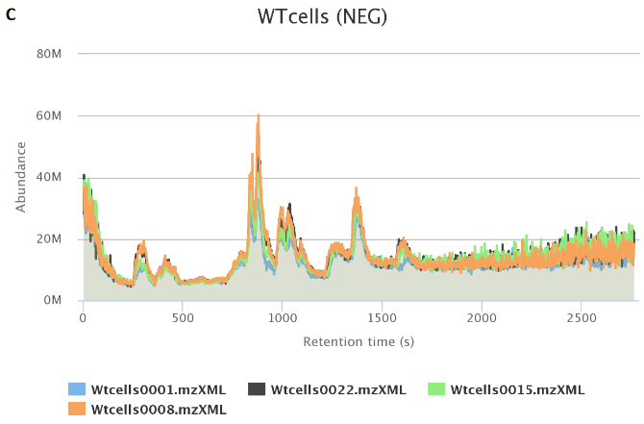

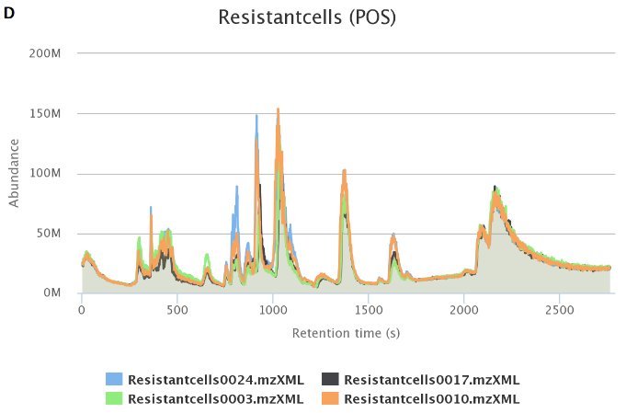 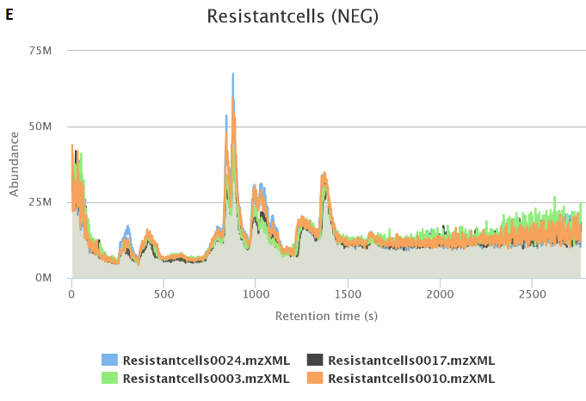

**Figure 2: Quality control visuals generated in PiMP**

A: Primary Component Analysis (PCA) plot of the 8 samples used in the analysis. WT cells are colour coded blue, resistant cells are colour coded black.

B -E: Total ion chromatogram (TIC) alignments. B shows how the TICs of each WT sample’s positive molecular ions compares. C shows how the TICs of each WT sample’s negative molecular ions compares.

Figures D and E are the respective equivalents of B and C, but for the resistant samples instead.

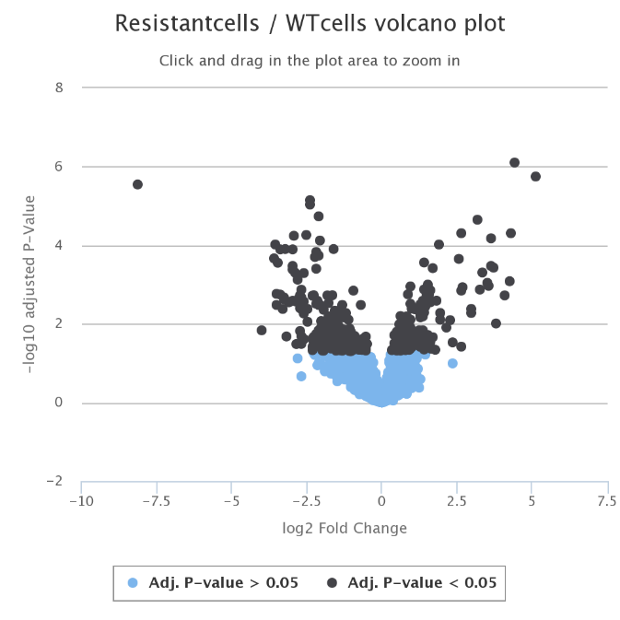

**Figure 3: Volcano plot**. Shows the relationship between the adjusted p-value and the log-fold change.

PiMP provided the KEGG metabolic pathway for metabolites it could map to the pathway, and it also performed a pathway analysis to show the significance at which metabolic pathways are affected. A metabolite (C29H6O) of m/z 411.362, which could be putatively identified as either 4,4 – Dimethyl-5-alpha-chloesta-8, 14, 24-trien-3beta-ol or delta 8, 14 – sterol, was found to be the most significantly increased metabolite in the resistant lines (Figure 4). There were several other isomers of this metabolite that we could not distinguish. These sterols are products of the enzyme sterol 14α demethylase (CYP51) (Hagrove *et al*, 2011; Mwenechanya *et al*, 2017). The peak identifying these sterols was detected from the molecular cation (no data for the molecular anion). Isomers of compund that mapped to glycolysis related pathways were found to be the most significantly decreased ones in the resistant cells, with an m/z of 445.0722 for the molecular cation, and 421.0748 for the molecular anion.

The observation of increased cholestane-type sterols in the resistant lines is consistent with that of previous studies (Mbongo *et al*, 1998; Hamdan *et al*, 2005; Purkait *et al*, 2012; Kumar *et a*l, 2014; Mwenechanya *et al*, 2017). However, these studies also reported that ergosterol was similarly decreased in AmpB resistant Leishmania. PiMP was not able to identify any ergosta-type sterols from the experiment, and thus we were unable to confirm this reduction.

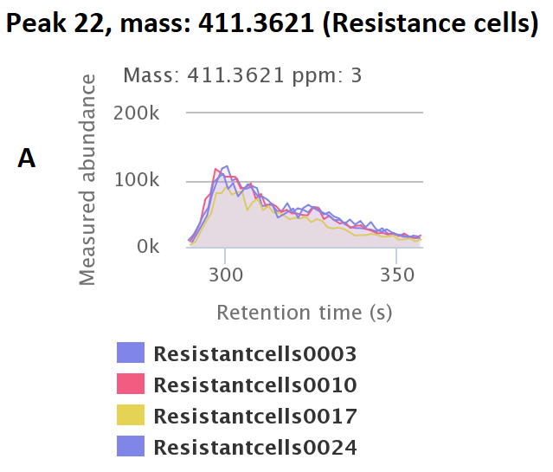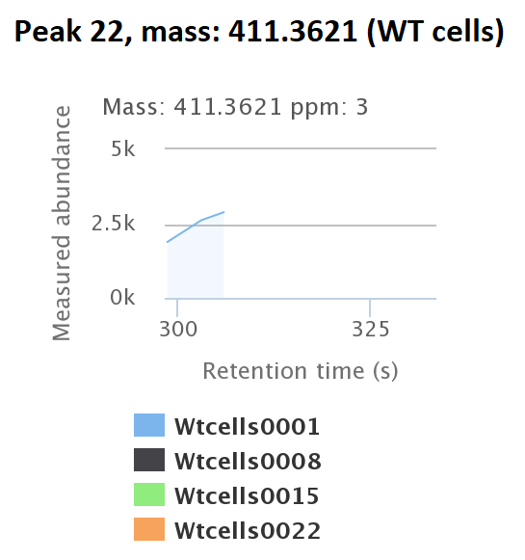

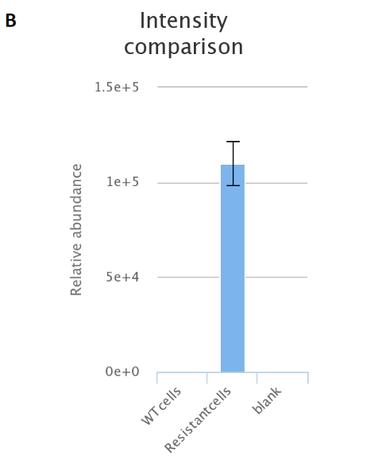

**Figure 4: Peak and intensity comparisons for the most significantly increased compound.**

A: Total ion chromatogram for the peak (peak 22) of the most increased compound in resistant cell lines (left) and the WT cell lines (right). The polarity for the molecular species is positive.

B: The relative abundance of the peak 22 compound in WT cells, resistant cells, and the blank.

Structural Biology analysis

The result of both the genome and metabolome analysis pointed to an amino acid change, N176I, in the sterol 14α demethylase (CYP51) as being associated with AmpB resistance. This phenomenon was also previously reported in a polyomics study carried out by Mwenechanya *et al*. (2017). In this study, the mutation site was revealed to be located outside the active site of the enzyme. They also demonstrated that the mutation does not affect localisation of the protein, nor the next protein in the pathway. Following these results from Mwenechanya *et al*. (2017), we aimed observe whether the mutation had an effect on the structure of the protein, or any interactions with the active site or the next enzyme in the pathway (i.e sterol C-14 reductase).

3D models of the WT CYP51 were generated using Phyre2 (Kelley *et al*, 2015), and I-TASSER (Yang *et al*, 2015). Ranking of the models via swiss-model’s QMEAN scoring function revealed that of Phyre2 to have the best global model quality (with a QMEAN4 value of -2.81). Due to time constraints, and the observed initial good quality modelling by Phyre2, the 3D models for the mutant CYP51 and sterol c14 reductase were generated just using Phyre2. The active site of the L. *mexicana* CYP51 model was annotated by aligning its structure to that of the experimentally determined L. *infantum* CYP51. The pairwise comparison of these two proteins revealed a 97.7% sequence identity, and a 99.2% sequence similarity. The RSMD for the alignment was 0.627 Å . The structure of the L. infantum CYP51 was incomplete, as the first 31 residues were missing. The WT and mutant CYP51 structures, as well as their active site, were also aligned, having a RSMD of 0.335 Å.Residues 2-17 of the CYP51 was predicted by CCTOP (Dobson *et al*, 2015) to be a transmembrane region.

The distance calculated between the mutation site and the active site, in both WT and mutatnt CYP51 structures, was to far apart to form any non-covalent interaction. This suggests that the residue at 176 does not alter the function of the enzyme; an observation consistent with our metabolomic analysis and previous studies (Mbongo *et al*, 1998; Hamdan *et al*, 2005; Purkait *et al*, 2012; Kumar *et a*l, 2014; Mwenechanya *et al*, 2017).The sterol c14 reductase structure was docked to both the WT and mutant CYP51 structures. The selection of docked conformations relied on the superimposition of similar c-14 reductase structures, and the orientation of the CPY51 transmembrane region towards the reductase, because the reductase had the classic conformation of a membrane protein (with a bundle of helices, relatively parallel to each other.

Discussion

The analysis carried out this study provided several layers of data, in the hope that upon integrating them, the mechanism of amphotericin B resistance can be elucidated by observing the system biology. Given that data from a genomic analysis were present, the outcome of the metabolomic analysis could be placed in the context of a metabolomic pathway. The pathway detected to be significantly affected, and that is most relevant to amphotericin B’s mechanism of action, was the steroid biosynthesis pathway. The first indication of this pathway arose from the metabolism enrichment analysis carried out on the list of protein coding variants identified in AmpB resistant L. *mexicana* genome. The enzymes encoded by the two genes enriching for the pathway have been implied to be associated with Leishmania AmpB resistance in previous studies (Mbongo *et al*, 1998; Hamdan *et al*, 2005; Purkait *et al*, 2012; Kumar *et a*l, 2014; Mwenechanya *et al*, 2017). The sterol 24-c-methyltransferase (SCMT) is one of the key enzymes involved in the production of ergosterol, without which, ergosterol is not produced. Previous studies have demonstrated that the absence SCMT activity is associated to the build-up of precursor sterols in resistant Leishmania cells. (Mbongo *et al*, 1998; Purkait *et al*, 2012). However, its products, the metabolites 24-Methleyne-cycloartanol and 24-Ethylidene-lophenol, were unidentified and not significantly changing, respectively. On the other hand, the products of the sterol alpha demethylase (CYP51), and its isomers, were the most significantly changing metabolites. As a result, the attention to Leishmania AmpB resistance was focused on the N176I mutation identified in the CYP51. As mentioned earlier, this association has also been previously identified (Mwenechanya *et al*, 2017).

The results from this study did not provide a conclusive explanation to how the N176I mutation confers resistance to AmpB in L. *mexicana*. The N176I mutation is located outside the active site of the CYP51 enzyme, and it was neither seen to interact with the active site nor with the next enzyme in the pathway. However, because these interactions were not observed does not mean that it does not happen. It was worth recalling that the model used was not experimentally determined, and thus could be a very low-resolution model. Also the method used for selecting docking conformations may not have been ideal. On the other hand, perhaps the residue 176 interacts indirectly with the sterol C-14 reductase enzyme, perhaps through a cofactor. One way to very this would be to annotate the unidentified peaks and have a look at the metabolomic data again; maybe even perhaps perform multiple target analysis to see which compounds form an interaction, and how strong the interaction is (via pKd calculation).

References

Bates AP. (2007). Transmission of Leishmania metacyclic promastigotes by phlebotomine sand flies. *International Journal for Parasitology*, 37(2007),:1097-1106.

Comeau SR, Gatchell DW, Vajda S, Camacho CJ. ClusPro: an automated docking and discrimination method for the prediction of protein complexes.*Bioinformatics*. 2004 Jan 1;  [pdf](https://structure.bu.edu/sites/default/files/comeau.pdf)   
  
Comeau SR, Gatchell DW, Vajda S, Camacho CJ. ClusPro: a fully automated algorithm for protein-protein docking *Nucleic Acids Research*. 2004 Jul 1;  [pdf](https://structure.bu.edu/sites/default/files/Cluspro_NAR.pdf)

Downing T, Imamura H, Decuypere S, Clark TG, Coombs GH, Cotton JA, Hilley JD, de Doncker S, Maes I, Mottram JC, Quail MA, Rijal S, Sanders M, Schönian G, Stark O, Sundar S, Vanaerschot M, Hertz-Fowler C, Dujardin JC, Berriman M.. (2011). Whole genome sequencing of multiple Leishmania donovani clinical isolates provides insights into population structure and mechanisms of drug resistance. *Genome Research*, 21(12), :2143-56.

Hargrove TY, Wawrzak Z, Liu J, David Nes W, Waterman MR, and Galina I. Lepesheva Gi. (2011). Substrate Preferences and Catalytic Parameters Determined by Structural Characteristics of Sterol 14!-Demethylase (CYP51) from Leishmania infantum. *The Journal of Biological chemistry*, 286(30), :26838-26848.

Kozakov D, Hall DR, Xia B, Porter KA, Padhorny D, Yueh C, Beglov D, Vajda S. The ClusPro web server for protein-protein docking. *Nature Protocols.*2017 Feb;12(2):255-278 ; [pdf](https://www.ncbi.nlm.nih.gov/pmc/articles/PMC5540229/pdf/nihms883869.pdf)   
  
Kozakov D, Beglov D, Bohnuud T, Mottarella S, Xia B, Hall DR, Vajda, S. How good is automated protein docking? *Proteins: Structure, Function, and Bioinformatics*, 2013 Aug ;  [pdf](https://www.ncbi.nlm.nih.gov/pmc/articles/PMC3934018/pdf/nihms556382.pdf)   
  
Kozakov D, Brenke R, Comeau SR, Vajda S. PIPER: An FFT-based protein docking program with pairwise potentials. *Proteins*. 2006 Aug 24;  [pdf](https://structure.bu.edu/sites/default/files/fft2006.pdf)

Kumar A, Sushmita Das, Bidyut Purkait, Abul Hasan Sardar, Ayan Kumar Ghosh, Manas Ranjan Dikhit,b Kumar Abhishek, Pradeep Dasa. (2011). Ascorbate Peroxidase, a Key Molecule Regulating Amphotericin B Resistance in Clinical Isolates of Leishmania donovani. *Antimicrobial Agents and Chemotherapy*, 58(10), :6172-6184.

Lepesheva GI, Barrett MP. (2017). Sterol 14α-demethylase mutation leads to amphotericin B resistance in Leishmania mexicana. *PloS neglected tropical diseases*, 1(6):e0005649. doi: 10.1371/journal.pntd.0005649. eCollection 2017 Jun.

Mbongo N, Loiseau PM, Billion MA, Robert-Gero M. (1998). Mechanism of amphotericin B resistance in Leishmania donovani promastigotes. *Antimicrobial Agents and Chemotherapy*, 42(2), :352-7.

Mwenechanya R, Kovářová J, Dickens NJ, Mudaliar M, Herzyk P, Vincent IM, Weidt SK, Burgess KE, Burchmore RJS, Pountain AW, Smith TK, Creek DJ, Kim DH,

Purkait B, Kumar A, Nandi N, Sardar AH, Das S, Kumar S, Pandey K, Ravidas V, Kumar M, De T, Singh D, Das P (2012). Mechanism of amphotericin B resistance in clinical isolates of Leishmania donovani. *Antimicrobial Agents and Chemotherapy*, 56(2), :1031-41.

Rogers MB, Hilley JD, Dickens NJ, Wilkes J, Bates PA, Depledge DP, Harris D, Her Y, Herzyk P, Imamura H, Otto TD, Sanders M, Seeger K, Dujardin JC, Berriman M, Smith DF, Hertz-Fowler C, Mottram JC. (2011). Chromosome and gene copy number variation allow major structural change between species and strains of Leishmania. *Genome Research*, 21(12), :2129-42.

WHO. (2017). Weekly epidemiological record. *World Health Organization*, 2017, 97, :557-572.

Note: This was a very rushed essay, there was not enough time to put up diagrams for structural stuff